

**Final Examination**

**NE 0407300**

**Fall 2024-2025**

* You have 120 minutes to complete the solution of the questions below.
* Be sure you put your name and UOS ID #.
* Write neatly and clearly.
* Illegible responses will not be graded.
* Divide your time carefully between the questions.
* *Academic dishonesty will result in* ***a zero mark*** *for the midterm exam and potential* ***F*** *in the course.*
* *Justify your assumptions and answers scientifically. Show detailed steps of your calculations.*
* *Use 4 significant digits in your answers whenever suitable.*

**Name: ID:**

|  |  |  |  |  |  |  |  |
| --- | --- | --- | --- | --- | --- | --- | --- |
| **Question** | **Q1** | **Q2** | **Q3** | **Q4** | **Q5** | **Q6** | **Total** |
| **Score** | /10 | /20 | /20 | /20 | /10 | /20 | /(100) |

**Q1)** A material has been discovered with a total thermal neutron cross section of 1200 barns, a neutron capture cross section of 250 barns, and a neutron scattering cross section 27 barns. Based on the information given, is it possible that this is a fissile material and what is the probability of fission interaction? **[10%]**

**Answer:**

**🡪 Most likely fissile since the fission probability is 76.92%**

**Q2)** Suppose that a fissile material is discovered for which all the neutrons are prompt. Furthermore,

suppose that a reactor fueled with this material has a prompt neutron lifetime of 0.002 s. **[20%]**

1. If the reactor is initially critical, and there is no source present, what period should the reactor be put on if it is to double its power in ten seconds **[10%]**?

**Answer:**

$$n\left(t\right)=n\left(0\right)\exp\left(\frac{k-1}{l}t\right)=n\left(0\right)\exp\left(\frac{t}{T}\right), T=\frac{l}{k-1}$$

$$T=\frac{t}{\ln\left(\frac{n\left(t\right)}{n\left(0\right)}\right)}=\frac{10}{\ln{2}}=14.4260 s$$

1. What is the value of the multiplication factor ($k$) in this case **[10%]**?

**Answer:**

$$T=\frac{l}{k-1}→k=1+\frac{l}{T}=1+\frac{0.002}{14.426}=1.000139$$

**Q3)** Given the Data below answer questions A and B **[20%]**:

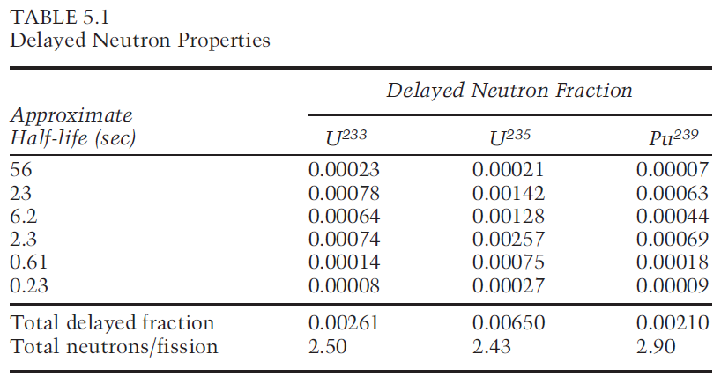

1. A power reactor is fueled with slightly enriched uranium. At the middle of core life 10% of the power comes from the fission of the built-up plutonium-239. Calculate the effective value of $β$ at the beginning and at the end of core life; determine the percent increase or decrease **[10%]**.

**Answer:**

$β_{eff}$**at BOC is $β_{eff}^{25}=0.0065$**

$β_{eff}$**at EOC is $β_{eff}=0.9×β_{}^{25}+0.1×β_{}^{49}=0.00606$**

1. Calculate the reactivity (in units of $ and $¢$) of the reactor above (initially critical) if its multiplication factor suddenly becomes $k=1.005$. **[10%]**

**Answer:**

$$ρ=\frac{k-1}{k}=0.00497{∆k}/k=497 pcm$$

$$ρ\left(\$\right)=\frac{ρ}{β}=\frac{0.00497}{0.00606}=0.82\$=82 ¢$$

**Q4) Long term core behavior [20%]**

1. 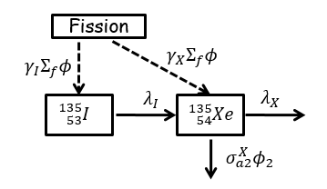Write down the balance equation(s) for Xe-135 **[10%]**

**Answer**: $$\frac{dI}{dt}=γ_{I}Σ_{fT}ϕ_{T}-λ_{I}I$$

$$\frac{dX}{dt}=γ_{X}Σ_{fT}ϕ_{T}+λ_{I}I-λ_{X}X-σ_{aT}^{X}ϕ_{T}X$$

1. Derive an expression for the steady state concentration of Xe-135 and I-135 based on the above-mentioned schemes? **[10%]**

**Answer:**

At equilibrium state $\frac{dI}{dt}=\frac{dX}{dt}=0$

$$I_{∞}=\frac{γ_{I}Σ_{fT}ϕ_{T}}{λ_{I}}$$

$$X_{∞}=\frac{λ_{I}I_{∞}+γ_{X}Σ_{fT}ϕ_{T}}{λ_{X}+σ_{aT}^{X}ϕ_{T}}=\frac{\left(γ_{I}+γ_{X}\right)Σ_{fT}ϕ_{T}}{λ_{X}+σ_{aT}^{X}ϕ_{T}}$$

**Q5) Reactivity & Control [10%]:**

1. The moderator temperature coefficient for a reactor is -12 pcm/ °F. Calculate the reactivity defect that results from a temperature decrease of 10°F. **[5%]**

**Answer:**

$$∆ρ=α_{M}ΔT=-12\frac{pcm}{℉}×-10℉=120 pcm$$

1. Plot approximate figures (with relative units) showing the differential and integral rod worth as a function of the insertion depth in the core (y-axis: the rod worth, x-axis: fraction distance from bottom of the core )? **[5%]**

**Answer:**

**Q6)** Consider a thermal reactor with the 6 factors’ values below **[20%]**:

$ε=1.04$, $η=2.01$, $p=0.81$, $f=0.751$, $P_{NL}^{f}=0.89$, $P_{NL}^{th}=0.90$

1. Estimate the multiplication factor of this reactor ? **[10%]**

**Answer: $$k=1.01856$$**

1. If the non-fuel thermal neutron absorption cross section increase by 10% in total, which factor will be affected by this change and what would be the updated value of the multiplication factor? **[10%]**

**Answer:**

The thermal utilization will be affected by this change: $$f^{'}=\frac{f}{1.1}=0.6827$$

$$k^{'}=\frac{k}{\begin{aligned}1.1 \\ \end{aligned}}=0.9259$$